**Design and implementation of Modern Compilers**

INDEX

|  |  |
| --- | --- |
| SR  NO | TITLE |
| 1 | Write a program to construct NDFA |
| 2 | Write a program to convert the given Right linear Grammar to Left Linear Grammar. |
| 3 | Write a code to generate DAG for input arithmetic expression. |
| 4 | Write a code to for triples. |
| 5 | Write a code for postfix evaluation. |
| 6 | Write a code to generate 3 address code |
| 7 | Write a code to demonstrate loop jamming for the given code sequence containing loop. |
| 8 | Write a code to demonstrate loop unrolling for the given code sequence containing loop. |

# Practical NO 1

**Aim** : Write a program to construct NDFA

Install package automata-lib By using the following command: pip install automata-lib

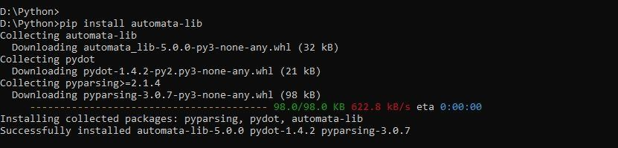

Code:

from automata.fa.nfa import NFA class NDFA: def __init__(self):

state_set = set(input("Enter state set>\t"))

input_symbols = set(input("Enter input symbol set>\t")) initial_state = input("Enter the initial state>\t") final_states = set(input("Enter the final state(s)>\t")) rule_count = int(input("Enter the number of rules you want to add>\t"))

rules = []

for counter in range(rule_count):

rules.append(input("Enter rule " + str(counter + 1) +

">\t").replace(" ", ""))

rules = self.get_transitions(rules)

self.nfa = NFA( states = state_set,

input_symbols = input_symbols, transitions = rules, initial_state = initial_state, final_states = final_states

)

del state_set, input_symbols, initial_state, final_states, rules.

def get_transitions(self, rules): rules = [i.split("-") for i in rules] rules_dict = {}

for rule in rules: if rule[0] not in rules_dict:

rules_dict[rule[0]] = {rule[1][1]:rule[1][0]} print("If:", rules_dict) else:

rules_dict[rule[0]][rule[1][0]] = rule[1][1] print("Else:", rules_dict) return rules_dict

def print_stats(self):

print("\n\nSet of states are > ", self.nfa.states) print("Input symbols are > ", self.nfa.input_symbols) print("Transitions are > ") for transition in self.nfa.transitions:

print(transition, self.nfa.transitions[transition]) print("Initial state > ", self.nfa.initial_state) print("Final states > ", self.nfa.final_states)

def print_transition_table(self):

input_symbols = list(self.nfa.input_symbols) transitions = self.nfa.transitions

print("\n\nTransition table is > ")

#print(f"States\t\t{input_symbols[0]}\t\t{input_symbols[1]}") print("States\t\t" + str(input_symbols[0]) + "\t\t" + str(input_symbols[1])) for transition in transitions: for input_symbol in input_symbols: try:

temp = transitions[transition][input_symbol] del temp except KeyError:

transitions[transition][input_symbol] = "-"

#print(f"{transition}\t\t{transitions[transition][input_symbols [0]]}\t\t{transitions[transition][input_symbols[1]]}")

print(transition + "\t\t" +

transitions[transition][input_symbols[0]] + "\t\t" + transitions[transition][input_symbols[1]]) del input_symbols, transitions if __name__ == "__main__":

ndfa = NDFA() ndfa.print_stats() ndfa.print_transition_table()

**Output**:

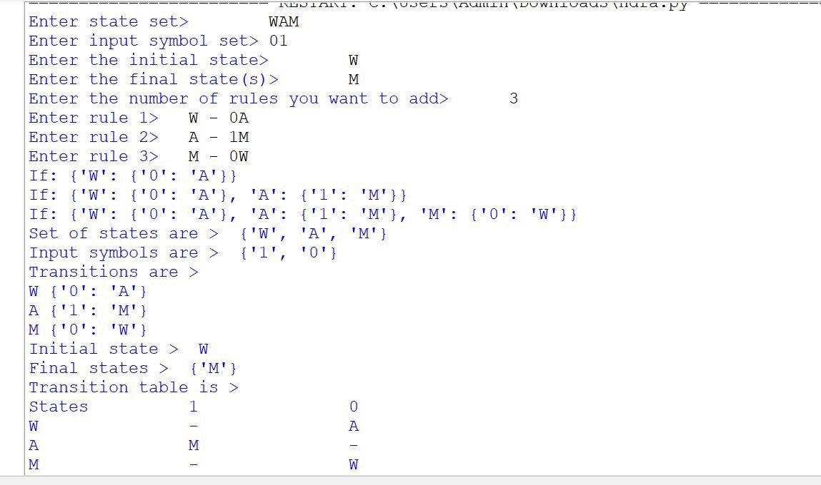

# PRACTICAL NO 2

**Aim**: Write a program to convert the given Right linear grammar to Left Linear Grammar form.

**CODE**:

def get_transitions(rules):

my_dict={}

ld='' res=dict()

r='' for i in rules:

my_dict[i[0]]=[i[1][1],i[1][0]] for sub in my_dict: if isinstance(my_dict[sub],list): res[sub]=ld.join([str(ele) for ele in my_dict[sub]]) print("Left linear grammar is:") for item in res: r+=item+"-"+str(res[item])+"\n" print(str(r))

rule_count=int(input("Enter rule count>\t"))

rules=[] for i in range(rule_count):

rules.append(input("Enter right linear grammar"+">\t")) rules=[i.split("->") for i in rules] print(rules) get_transitions(rules)

**OUTPUT**:

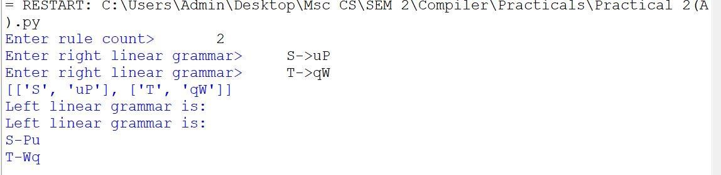

# PRACTICAL NO 3

**Aim**: Write a code to generate DAG for input arithmetic expression.

**CODE**:

def func(x):

main = []

for i in range(0,x):

y = input()

main.append(y)

print("Label Operator Left Right")

for i in range(0,x):

q = main[i]

if q[0] not in res:

res.append(q[0])

if (len(q)>3):

print(" ",q[0]," ",q[3]," ",q[2]," ",q[4])

else:

print(" ",q[0]," ",q[1]," ",q[2]," ")

print(main)

print(res)

x = int(input("enter the number of 3 address code: "))

res = []

func(x)

**Output**:

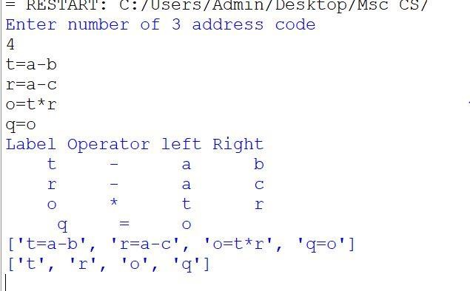

# PRACTICAL NO 4

**Aim**: Write a code for triples.

**Code**:

def func1(x):

main = []

for i in range(0,x):

y = input()

main.append(y)

print("address operator argument1 argument2")

for i in range(0,x):

q = main[i]

if q[0] not in res:

res.append(q[0])

e = func2(q[2])

if (len(q)>3):

r = func2(q[4])

print(" (",i,")"," ",q[3]," ",e," ",r)

else:

print(" (",i,")"," ",q[1]," ",e," ",)

print(main)

print(res)

def func2(q):

try:

z = res.index(q)

return(z)

except:

return(q)

x = int(input("enter the number of productions: "))

res = []

func1(x)

**Output**:

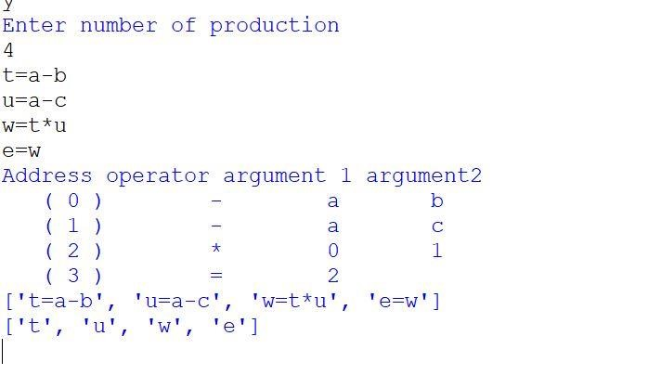

# PRACTICAL NO 5

**Aim**: Write the code for Postfix Evaluation

**CODE**:

def postfix_evaluation(s):

s=s.split()

n=len(s)

stack=[]

for i in range(n):

if s[i].isdigit():

stack.append(int(s[i]))

elif s[i]=="+":

a=stack.pop()

b=stack.pop()

stack.append(int(a)+int(b))

elif s[i]=="*":

a=stack.pop()

b=stack.pop()

stack.append(int(a)*int(b))

elif s[i]=="/":

a=stack.pop()

b=stack.pop()

stack.append(int(a)/int(b))

elif s[i]=="-":

a=stack.pop()

b=stack.pop()

stack.append(int(a)-int(b))

return stack.pop()

s="8 7 8 * + 4 -"

val=postfix_evaluation(s)

print(val)

**OUTPUT**:

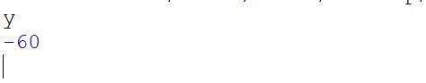

# PRACTICAL NO 6

**Aim**: Write a code to generate 3 address code

**Code**:

postfix = input("enter postfix operator:").split()

operators = ['+','-','/','*','^']

stack = []

result = ' '

str1 = ' '

count = 0

print("3-ADDRESS CODE")

for i in postfix:

if i not in operators:

stack.append(i)

#print("stack = ",stack)

else:

op1 = stack.pop()

op2 = stack.pop()

result = op2+i+op1

str1 = 'T' + str(count)

stack.append(str1)

print("T", count, "=", result)

count += 1

**Output**:

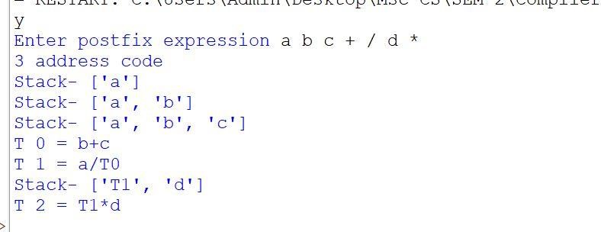

# PRACTICAL NO 7

**Aim**: Write a program to demonstrate loop jamming for given code sequence containing loop.

**Code**:

from time import time

def test_jamming(array_1, array_2, array_3):

start_time = time()

for l in range(1000000):

sum = 0

for i in range(len(array_1)):

sum += array_1[i]

for j in range(len(array_2)):

sum += array_2[j]

for k in range(len(array_3)):

sum += array_3[k]

intermediary_time = time()

for l in range(1000000):

sum = 0

for i in range(len(array_1)):

sum += array_1[i]

sum += array_2[i]

sum += array_3[i]

end_time = time()

print(f"time required to execute loop1: {intermediary_time - start_time}")

print(f"time required to execute loop2: {end_time - intermediary_time}")

array_1, array_2, array_3 = [[10,20,30], [40,20,30], [20,10,40]]

test_jamming(array_1, array_2, array_3)

**Output:**

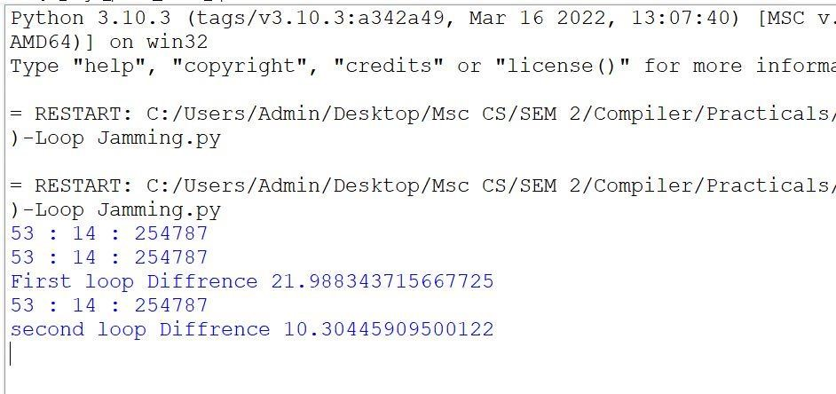

# PRACTICAL NO 8

**Aim**: Write a program to demonstrate loop unrolling for given code sequence containing loop.

**Code**:

import time

from datetime import datetime def funct1(): arr=[] arr1=[] t1=datetime.now() start=t1.microsecond print(start) for i in range(0,1000):

arr.insert(0,i) print(arr) t2=datetime.now() end1=t2.microsecond print(end1)

for i in range(0,1000,4):

arr1.insert(0,i) arr1.insert(0,i+1) arr1.insert(0,i+2) arr1.insert(0,i+3) print(arr1) t3=datetime.now() end2=t3.microsecond print(end2)

print("Before unroling:",end1-start) print("After unroling:",end2-end1) funct1()

**OUTPUT**:

